Voyage Analytics: Integrating MLOps in Travel:

Submitted by: Manjula M
Batch: AI/ML
Date: 13-02-2026
GitHub Link: https://github.com/Manjula1989/Amazon-Delivery-Time-Prediction.git

Abstract
This project demonstrates the application of MLOps principles in the travel domain by developing, tracking, and deploying a machine learning model for flight price prediction. The system integrates model training, experiment tracking using MLflow, and deployment through a REST API, ensuring an end-to-end production-ready machine learning workflow.

Introduction
The travel industry generates large volumes of data related to users, flights, and hotels. Accurate price prediction helps users and businesses make informed decisions. This project focuses on building a machine learning solution and productionizing it using MLOps practices.

Objectives
- Build a regression model to predict flight prices
- Perform data preprocessing and feature engineering
- Track experiments using MLflow
- Deploy the trained model using a REST API
- Demonstrate end-to-end ML production workflow

Dataset Description
The project uses three datasets:
• users.csv – Contains user-related information
• flights.csv – Contains flight details such as source, destination, flight type, distance, and price
• hotels.csv – Contains hotel-related information

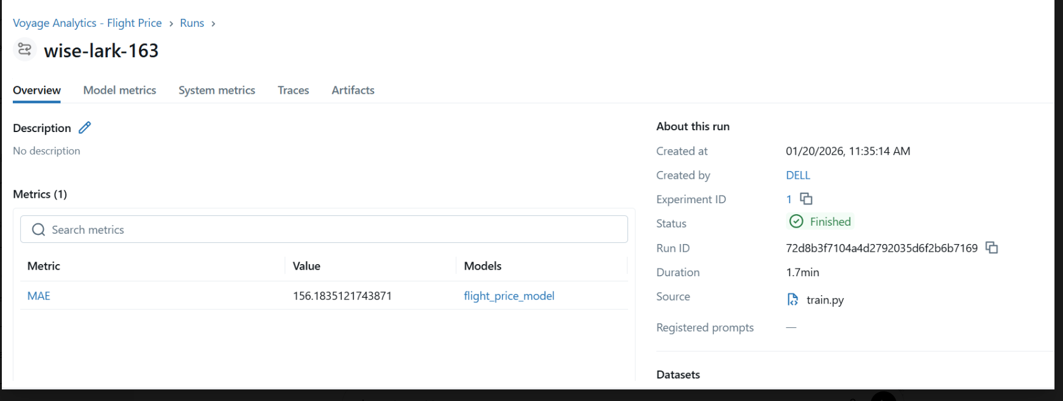
Figure 1 shows a preview of the flight dataset used for training the machine learning model. The dataset contains information such as source, destination, flight type, distance, and price.

Methodology
Data preprocessing involved cleaning the data, selecting relevant features, and encoding categorical variables. A RandomForestRegressor model was trained using a train-test split. Model performance was evaluated using Mean Absolute Error (MAE).

Model Development and Evaluation
The RandomForestRegressor algorithm was selected due to its robustness and ability to handle non-linear relationships. The trained model achieved an MAE of approximately 156, indicating reasonable prediction accuracy for the dataset.

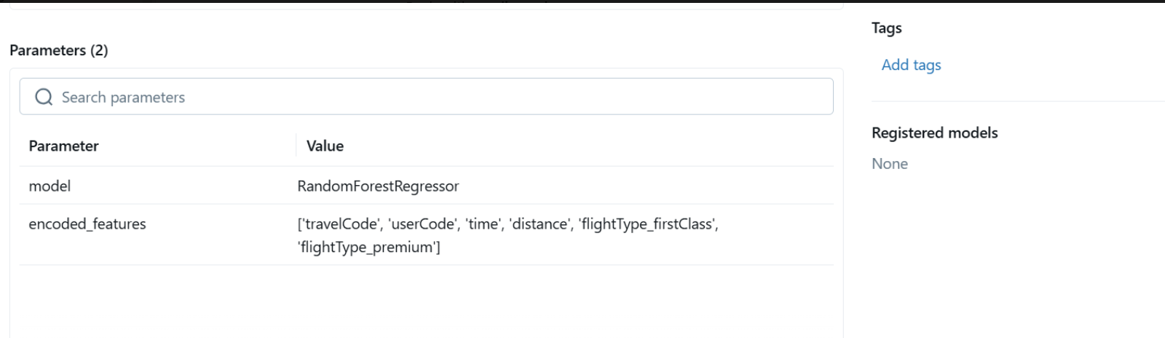

Figure 2 illustrates the successful training of the RandomForest regression model. The model performance was evaluated using Mean Absolute Error (MAE).

MLflow Experiment Tracking
MLflow was used to track machine learning experiments. Parameters, metrics, and model artifacts were logged, enabling reproducibility and experiment comparison. The trained model was saved as an artifact for deployment.

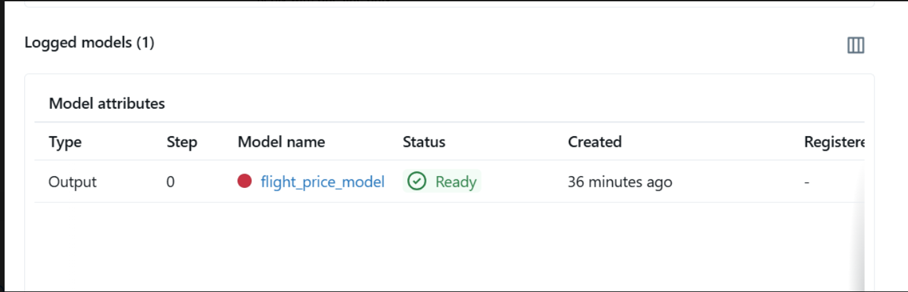
Figure 3 shows the MLflow experiment dashboard used to track model training runs. MLflow enables logging of parameters, metrics, and model artifacts.
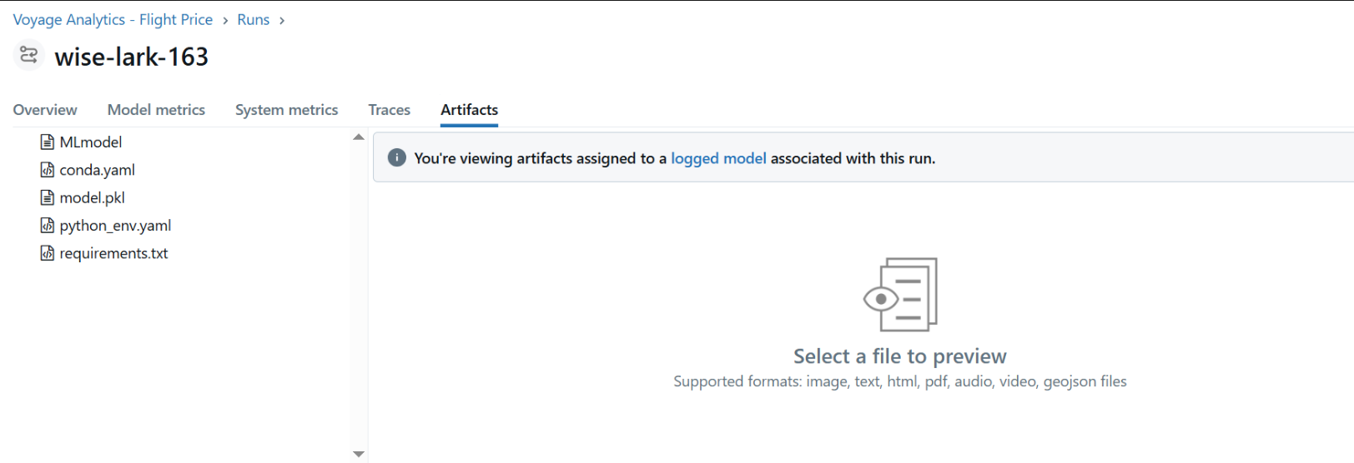
Figure 4 presents detailed run information including evaluation metrics and stored model artifacts. This ensures reproducibility and version control of the trained model.

REST API Deployment
A Flask-based REST API was developed to serve the trained model. The API exposes a /predict endpoint that accepts JSON input and returns predicted flight prices, enabling real-time inference.

Results
The deployed API successfully generated flight price predictions. The complete pipeline from data ingestion to prediction was validated, demonstrating a production-ready ML system.

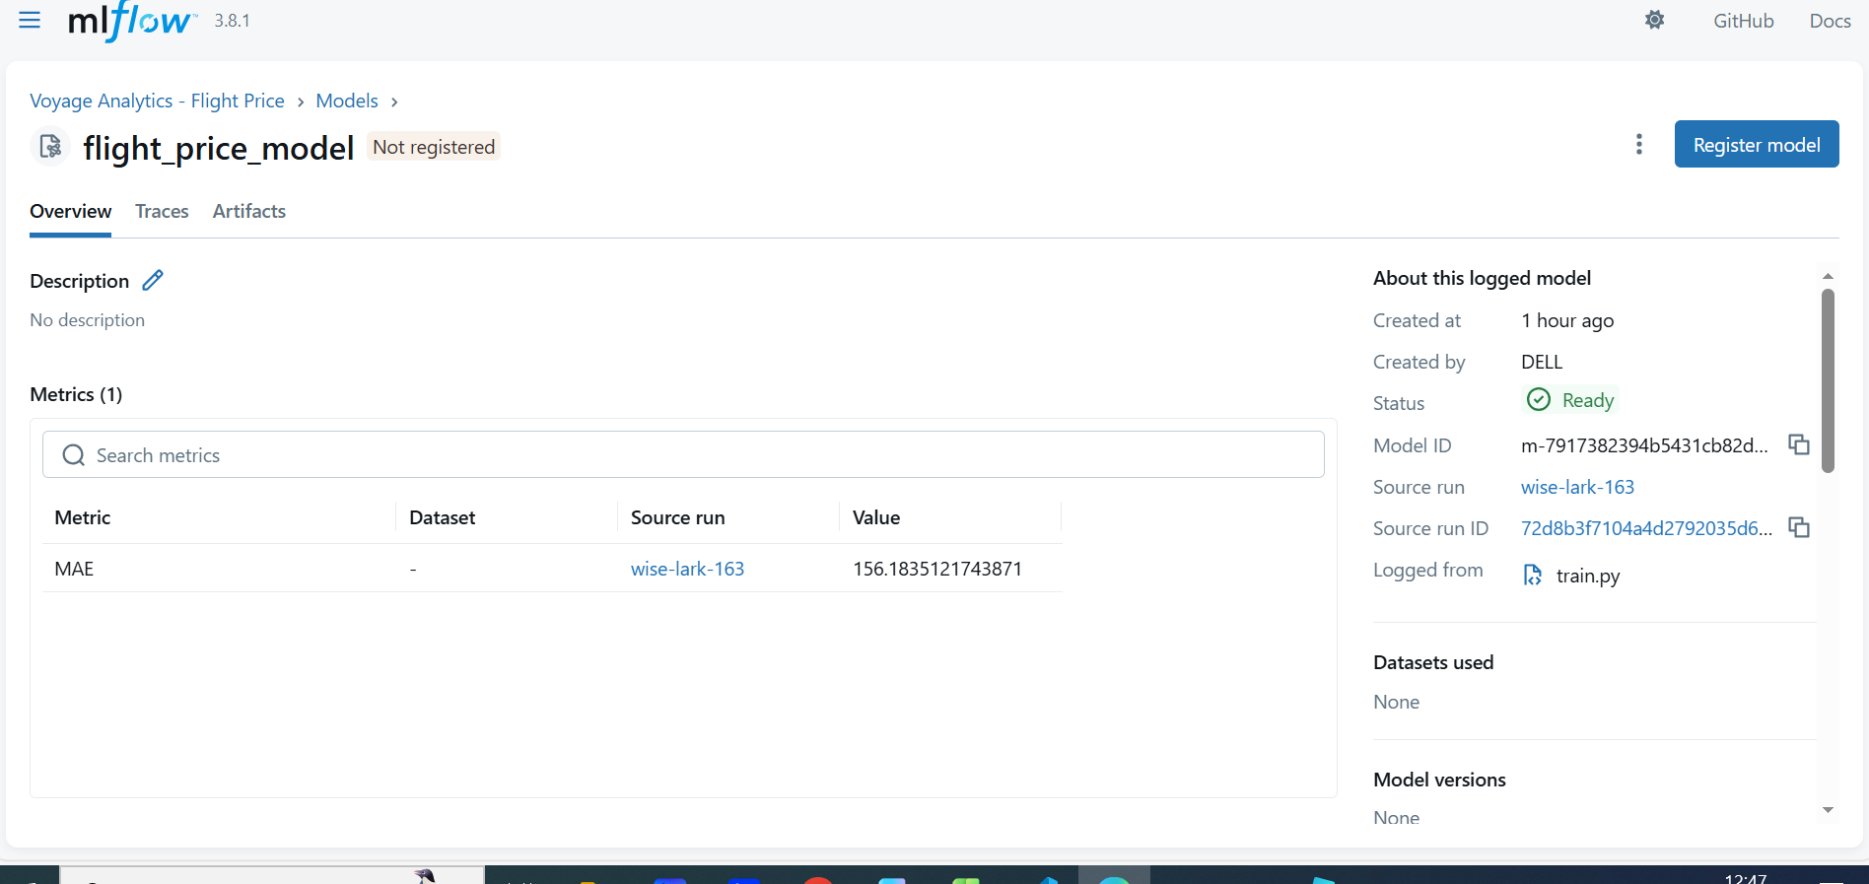
Figure 5 shows the prediction output generated by the deployed REST API. The system successfully returns the predicted flight price for the given input parameters.

Tools and Technologies Used
Python, Pandas, Scikit-learn, MLflow, Flask, VS Code

Limitations and Future Enhancements
The current system focuses on core MLOps functionality. In the future, Docker can be used for containerized deployment, and Kubernetes can be implemented for scalability and fault tolerance.
Docker-based containerization can be integrated to package the machine learning model, dependencies, and REST API into a single portable unit. This would ensure consistent deployment across different environments and simplify production deployment. Due to system and infrastructure constraints, Docker was not implemented in the current phase and is proposed as a future enhancement.
Kubernetes orchestration can be utilized in future to manage containerized deployments, enabling scalability, load balancing, and fault tolerance. Since the current project focuses on functional MLOps implementation, Kubernetes deployment is proposed as a future scope.

Conclusion
This project successfully demonstrates the productionization of a machine learning system using MLOps practices. By integrating model development, experiment tracking, and API deployment, the system provides a scalable foundation for real-world travel analytics applications.

Future Work
The current implementation focuses on demonstrating an end-to-end MLOps pipeline for flight price prediction. The system can be further enhanced in the following ways:
- Integration of Real-Time Data
Incorporating real-time flight availability, seasonal demand, and dynamic pricing data can improve prediction accuracy and make the system more responsive to market changes.
- Advanced Predictive Analytics
Additional machine learning and deep learning models can be explored to improve performance and enable route-level and demand-based price optimization.
- Personalized Recommendation System
A recommendation engine can be developed to suggest optimal travel options to users based on historical behavior, preferences, and budget constraints.
- Improved User Interface and Visualization
A web-based interface (using tools such as Streamlit) can be enhanced to support batch uploads, interactive dashboards, and advanced visual analytics for better user experience.
- Scalable Deployment Architecture
Containerization using Docker and orchestration using Kubernetes can be implemented to support scalable and fault-tolerant deployment in production environments.

📚 References:

- Pandas Documentation
https://pandas.pydata.org
- Scikit-learn Documentation
https://scikit-learn.org
- MLflow Documentation
https://mlflow.org
- Flask Documentation
https://flask.palletsprojects.com
- Streamlit Documentation
https://docs.streamlit.io

